Guide Permesso |  | 2023-06-09 | 1
Filip Janbell | HMO | Fredrik Rauer | HMO

GUIDE PERMESSO – MARITIME PERMIT APPLICATIONS

This manual is a guide to user registration, login and use of the Permesso application for maritime permit application. The manual is a support for entrepreneurs and vessels conducting activities and work in the port area that require notification and permit from Port Control.

CONTENT

GUIDE PERMESSO – MARITIME PERMIT APPLICATIONS 1
Login 2
Forgot password. 2
First time login 3
Handling of users 4
Functions 4
Edit user details 4
Work permits 5
Create a new Work permit 5
Troubleshooting and contact info 9

Login

To get access to Permesso and apply for work permits you need to contact Port Control and they will create an account for you to the system. Send an e-mail with the following information to: portcontrol@portgot.se

- First name and family name
- E-mail (your e-mail will be the username)
- Phone number
- Company name

When the registration is completed you will get a confirmation e-mail with a link to login at Permesso.
Username is your e-mail and the password will first be temporary chosen by Admin Port Control.

Forgot password.
When you login for the first time click on the ”Forgot Password?” button. A new, personal password will thus be chosen and Port Control avoids sending password by e-mail.

How to do:

- Click on the link permesso.goteborgshamn.se
- Choose english language
- Click on ”Forgot Password?”
- Write your e-mail in the adress field
- Check your inbox (also check junkmail)
- Click on the link in the e-mail
- Choose a new personal password. (At least 12 characters, both capital and lower case letters, number, special character)
- Now you can login to the system with your new personal password.

Se pictures how it looks in Permesso.
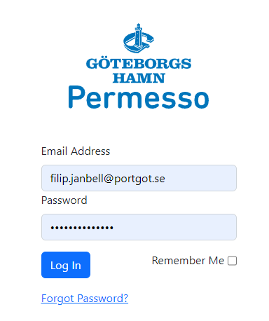

When you clicked ” Forgot Password” you will se the reset password field.
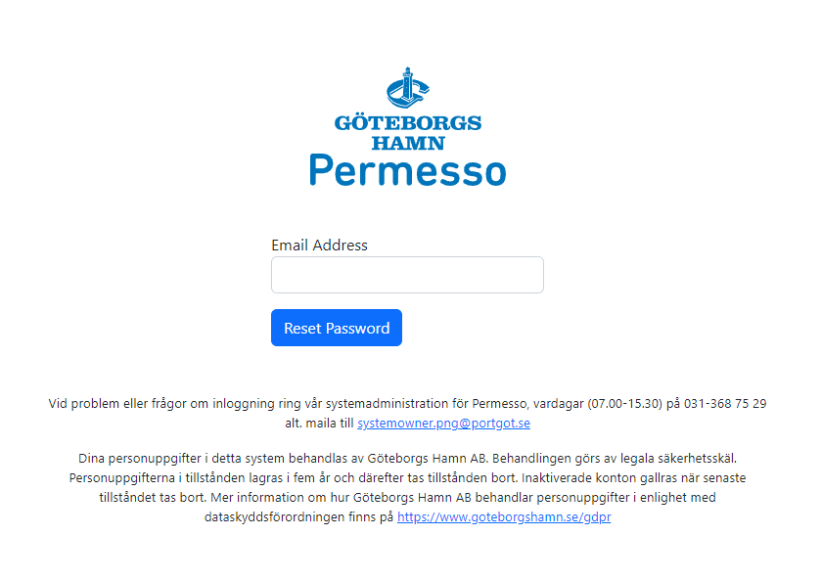

First time login

The first time you login to the system it will appear a dialog box that needs your approval. It’s for the approval of Port of Gothenburgs handling of your personal data according to GDPR (General Data Protection Regulation). You need to accept this to be able to use Permesso.

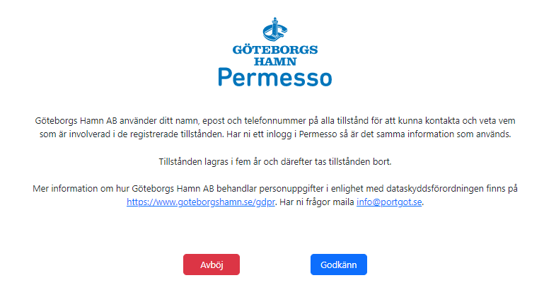
If you press ”Deny” your login will be failed and your accound will be blocked.

Handling of users

You will be assigned the role external case manager by Port Control – This funtion is for all external workers who performs work permit required activities General port Regulations. This function can create work permit applications to be approved by Port Control.

Edit user details

If a user needs to change their user information or password he/she can change it. Click on the cogwheel and email-adress in the upper right corner. A drop down menue will be displayed.

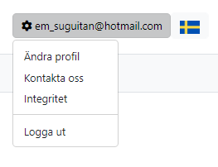
Choose ”Ändra profil” to make changes.

Work permits

Permesso will handle both notifications and permit applications for maritime activities and work in the Port Area which are required by the Port Authority.

Create a new Work permit
All users with a personal login in Permesso are able to create a work permit but it’s only Admin Port Control that can approve it.

To create a new work permit click on ”Work Permit Port Control” up in the right corner and you will have a list with all Work Permit Applications.

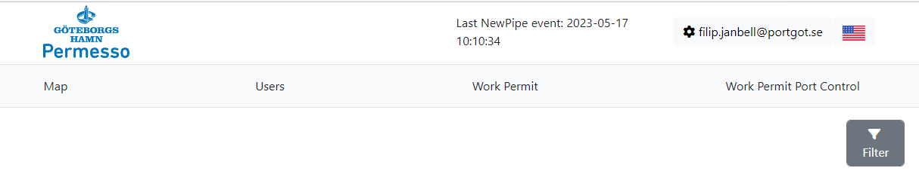

Click on the desired work permit and the application form will be showed. Click on the blue position symbol and a map view where you choose position for the work will appear.

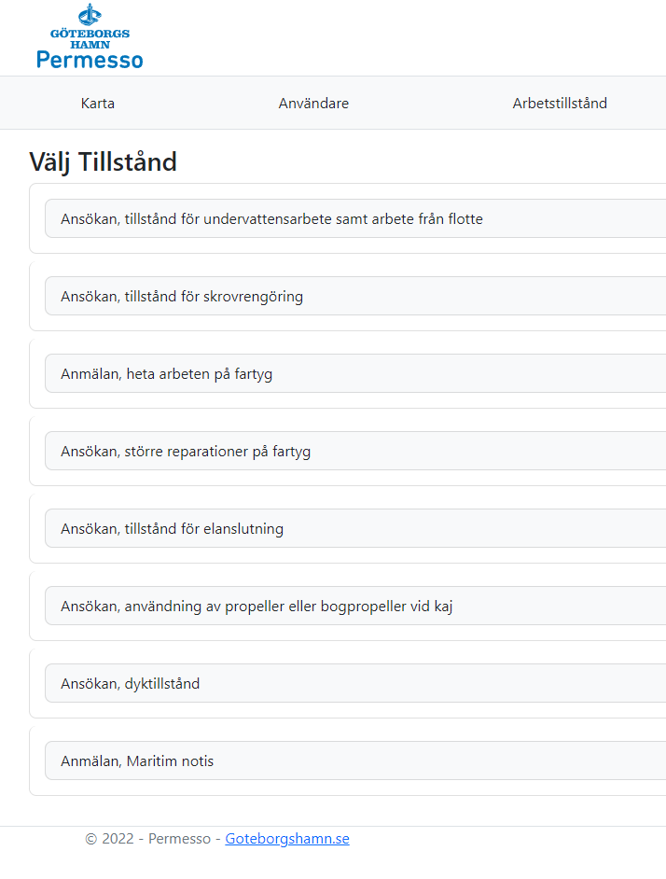

Move the cursor to the desired position of the work and left click. You will now get a Lat/long position. If you’re satisfied with the position click on ”Save position”. When you’ve done that you will get back to the application form with the postition saved. You can now fill in the rest of the application form.
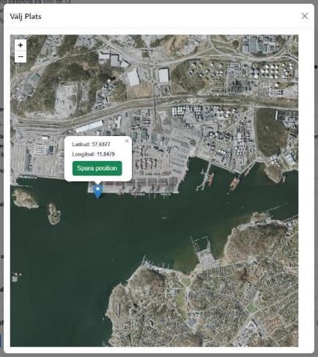

When every field in the application form is completed click on ”Send” down in the right corner. The work permit is now registered waiting for approval by Port Conrol.

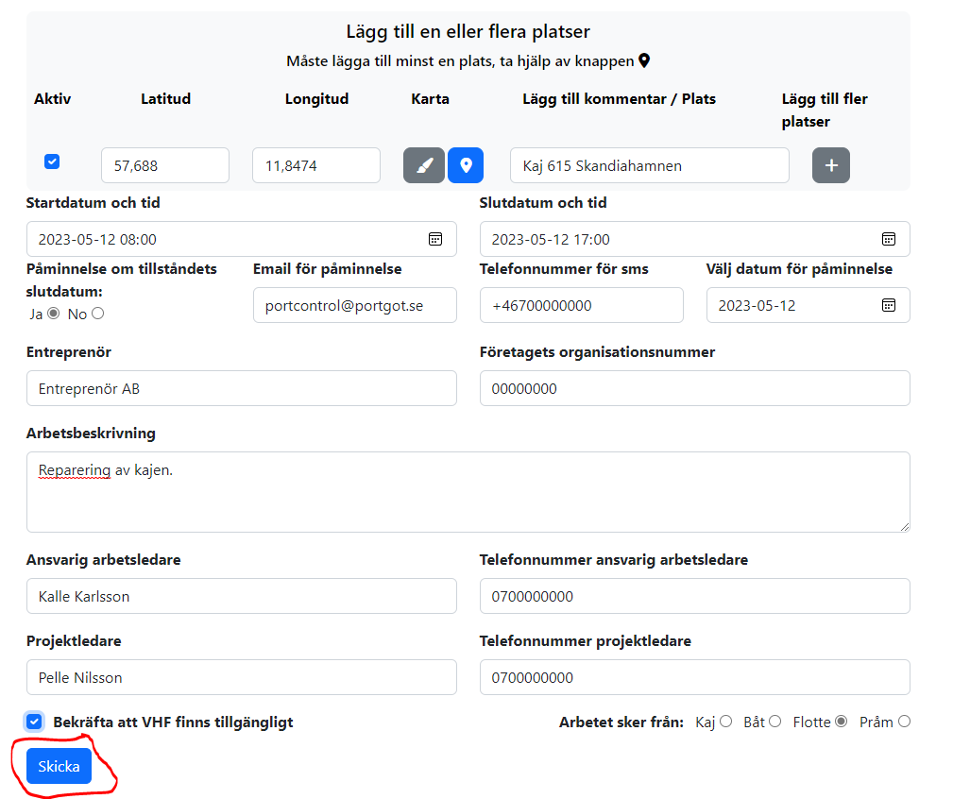
When the permit is registered the symbol is blue.

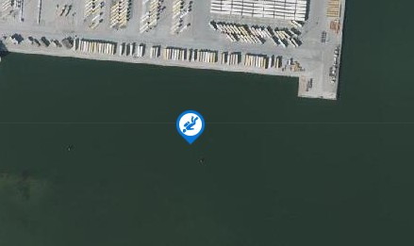

When the permit is approved by Port Control the symbol turns green. The user will also get an e-mail with confirmation that the work permit is approved.
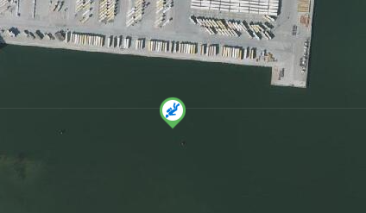

Troubleshooting and contact info

Any questions regarding the steps in this manual or other Permesso-related to Permesso can be posed to Port Control.

Don’t hesitate to contact us.

Contact details

Portcontrol@portgot.se
+46313687515

